Chapter 18, Solution 53.

If f(t) = e^{-2|t|}, find 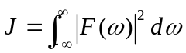.

J = 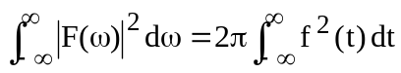

f(t) = 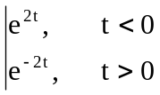
J = 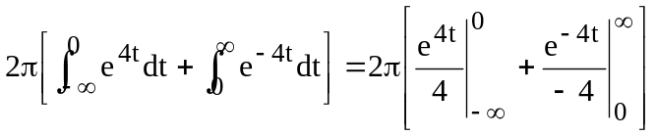 = 2π[(1/4) + (1/4)] = π

